Abstract class in Java->

A class that is declared with abstract keyword, is known as abstract class in java. It can have abstract and non-abstract methods (method with body).

**Abstraction in java->**

**Abstraction** is a process of hiding the implementation details and showing only functionality to the user.

Ways to achieve Abrastaction->

1.abstact class.

2.interface.

rules for abstract class->

*abstaract class c++ me abstract keywrod ni hota h uske liye pure virtual function bnteh

*abstarct class ka object ni bna skte,its for only inheritance other class inherit abstraction class,

*aBSTRACT CLASS KA REFRECE VARIABLE BN SKTA H.but object ni.

ANOTHER EXAMPLE OF ABSTRACT CLASS->

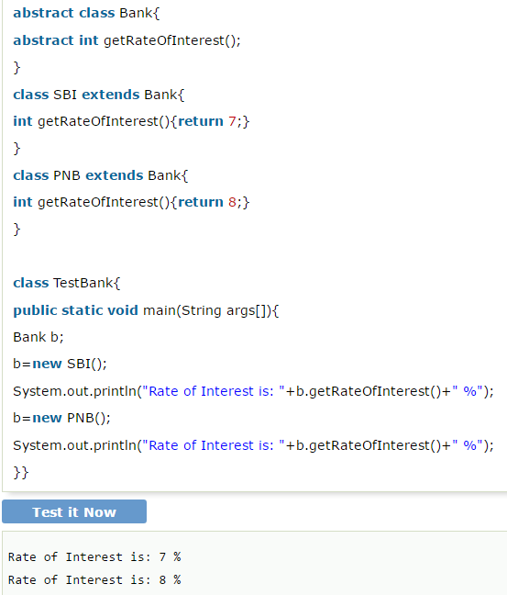

Rules->

### **\*Abstract class having constructor, data member, methods etc.**

**\*If there is any abstract method in a class, that class must be abstract.**

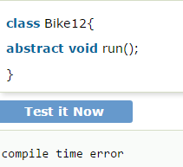

interfernce in java->

*An **interface in java** is a blueprint of a class. It has static constants and abstract methods.

*The interface in java is **a mechanism to achieve abstraction**.

* There can be only abstract methods in the java interface not method body.

* It is used to achieve abstraction and multiple inheritance in Java.

* Java Interface also **represents IS-A relationship**.

WHy use of java Interface?

* It is used to achieve abstraction.
* By interface, we can support the functionality of multiple inheritance.
* It can be used to achieve loose coupling.

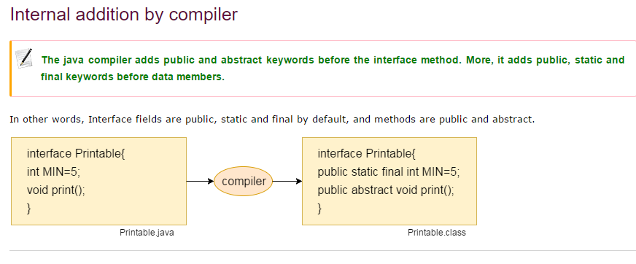

#### **Understanding relationship between classes and interfaces->**

* a class extends another class,

* an interface extends another interface

* c**lass implements an interface**.

Java INterface exapmle->

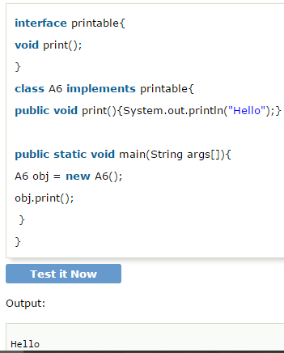

## Java **Interface Example: Drawable->**

**In this example, Drawable interface has only one method. Its implementation is provided by Rectangle and Circle classes.**

**In real scenario, interface is defined by someone but implementation is provided by different implementation providers.**

**And, it is used by someone else. The implementation part is hidden by the user which uses the interface.**

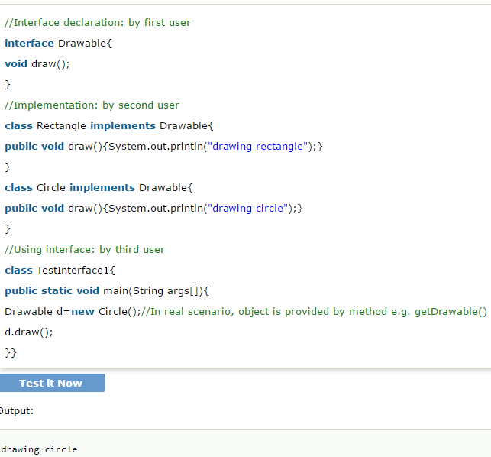

## **Multiple inheritance in Java by interface->**

**\*If a class implements multiple interfaces, or an interface extends multiple interfaces i.e. known as multiple inheritance.**

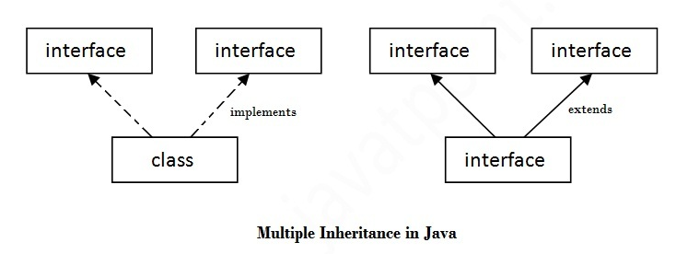

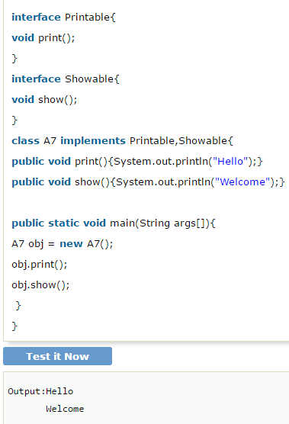

## **Q) Multiple inheritance is not supported through class in java but it is possible by interface, why?**

because there is no ambiguity as implementation is provided by the implementation class.

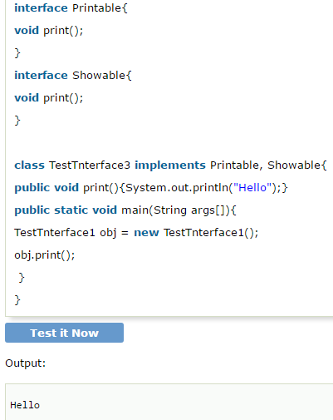

A class implements interface but one interface extends another interface .

## **What is marker or tagged interface?**

->

*An interface that have no member is known as marker or tagged interface. For example: Serializable, Cloneable, Remote etc. They are used to provide some essential information to the JVM so that JVM may perform some useful operation.*

*to use abstract class construcotre you use super instead of class name;*